**Task No. 1:** Analyze the above network, deactivate another working interface and monitor

the shift to the redundant interface. Also, change the root switch to a switch of your choice and implement the rapid STP and finally show the pinging results.

**Solution**

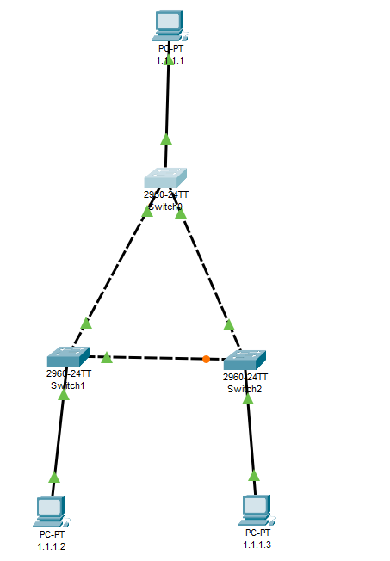

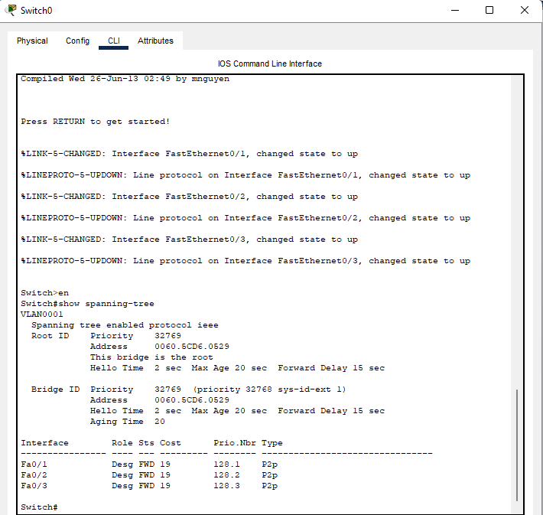

**Switch 0 is the Root**

**Shutdown Command**

**Switch 0**

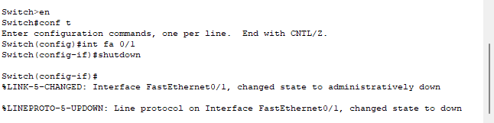

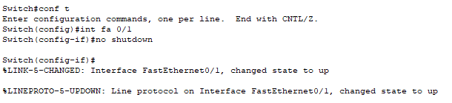

**Switch 1 is the Root**

|  |  |
| --- | --- |
| **PC** | **IP ADDRESS** |
| **PC 1** | **1.1.1.1** |
| **PC 2** | **1.1.1.2** |
| **PC 3** | **1.1.1.3** |

**Another Way of Making Root**

**Switch 2 is the Root**

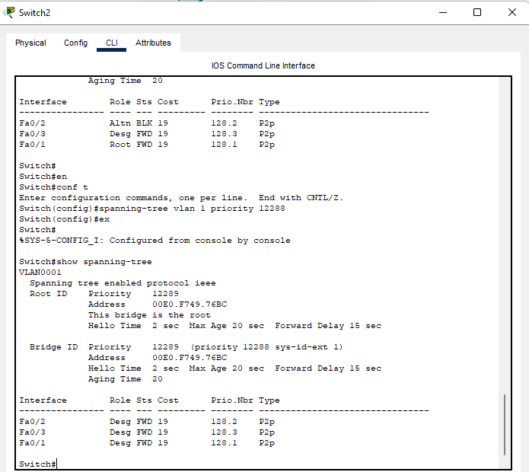

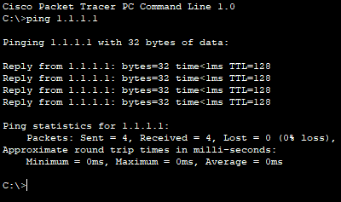

**Ping PC3 to PC1**

**Ping PC1 to PC2**

**Ping PC1 to PC3**

**Ping PC2 to PC3**